**Adding Images to your webpage**



Adding large images can make your webpage hard to navigate, a good size to go by is 400 x 600 pixels. But another option again, is to add the image as a thumbnail, and then make that small image a link to your larger image. Take a look at how we did this:

**1.** Here is your main webpage, with the thumbnail image, this is actually a link!

**5.** Add the full size image (as a link) to your main webpage. Use the **<a>** element.

**1.** Make a thumbnail image copy of your original image, try 100 x 150 pixels. (Use a photo editing application for this, for example Paint).

6. Add the thumbnail to the link that you just created, using the **<img>** element.



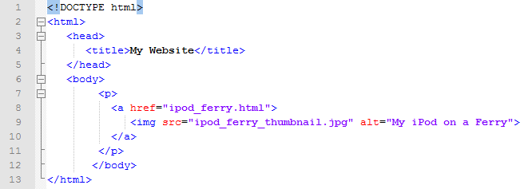

**2.** Here is the full sized image, that lives in it’s own webpage.

**2.** Create a new webpage for the full size image. Add the image using the **<img>** element.

**3.** Here is the alt message that will be displayed if your image doesn’t load.



**3.** Use the **src** attribute, to tell the webpage where the image is stored.

**4.** If the image can’t be displayed on your webpage, then the **alt** attribute is used in it’s place. It’s also used by screen readers for the visually impaired.

